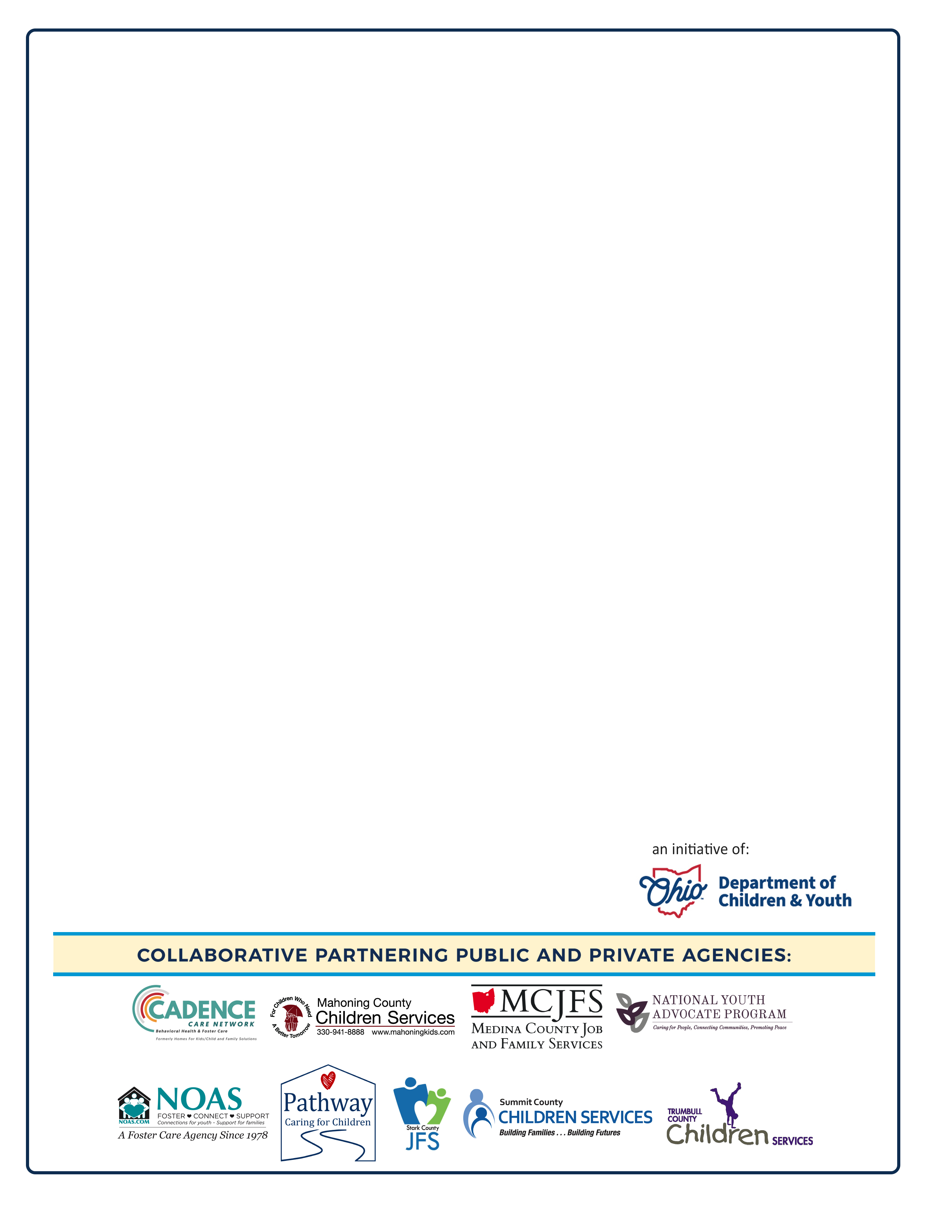
To: Media Contacts

Contact: Ann Ream, Department Director, Community Relations, Summit County Children Services

FOR IMMEDIATE RELEASE: February 23, 2024

Nine Local Foster Care Agencies Launch “Take a Leap into Foster Care” Campaign to
Recruit and License Foster Caregivers for Hundreds of Northeast Ohio Children

Akron, Ohio: Nine northeast Ohio public and private agencies that recruit foster caregivers for abused and neglected children have joined together to raise awareness about the dire shortage and great need for more licensed foster caregivers within their service areas. The agencies are launching a year-long awareness campaign: “Take a Leap into Foster Care,” launching on Leap Day 2024.

The campaign is designed to educate interested individuals on how to become a licensed foster caregiver, provide information about the licensing process, dispel myths about the foster care system.

“We are always happy to answer the community’s questions,” said Traci Foley, Department Director, Placement Services. “We are hoping for more licensed foster caregivers in the same neighborhoods where children are being removed from their homes, through no fault of their own. They need loving, stable, and safe options in Summit County.

“There are currently more than 14,800 children in Ohio’s foster care system and only 7,000 licensed foster caregivers,” said Kara Wente, director of the Ohio Department of Children and Youth. “We applaud and support local agencies for recognizing the need and acting on it to ensure all children have opportunity to feel safe and supported.”

The agencies will hold nine separate Kick-off events to launch the “Take a Leap into Foster Care” campaign. Each partnering agency will implement their own exclusively designed event within their respective community. All the kick-off events will be held on the same day—Leap Day:

Thursday, February 29, 2024

Summit County Children Services (SCCS) will host a virtual Foster Care Open House. A panel of SCCS Foster parents will share their journey through the foster care experience via Zoom on Thursday, February 29, 2024, at 6pm. For those interested in becoming a foster parent with SCCS, please register at summitkids.org or by calling the Inquiry line at 330-379-1990.
Last year, SCCS provided services to 1 out of every 12 children in Summit County.

