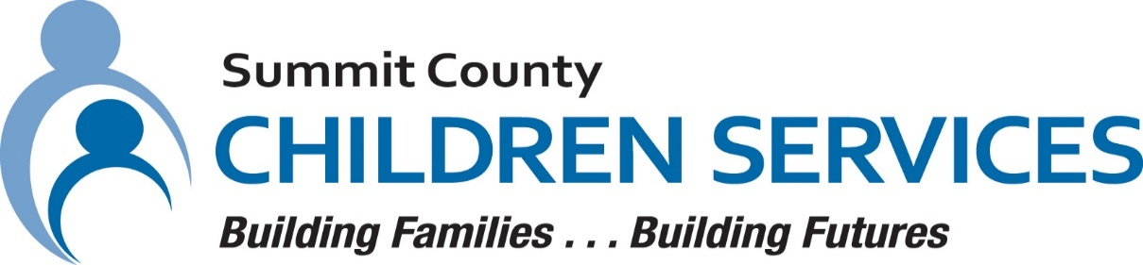

MEDIA RELEASE

Summit County Children Services 264 South Arlington Street Akron, Ohio 44306

FOR IMMEDIATE RELEASE Contact: Ann Ream
Department Director, Community Relations

(330) 379-2070
Ann.Ream@summitkids.org

Summit County Children Services Tammy Luhring Recognized with State Award

AKRON, OHIO – October 2023 – Tammy Luhring left a legacy of passion and commitment after her 31 years of work at Summit County Children Services (SCCS). She served a variety of roles and dedicated every day to serving the children and families in Summit County. The Public Children Services Association of Ohio (PCSAO) recognized her outstanding children services work and posthumously presented her with the 2023 PCSAO Caseworker of the Year award, which her family accepted on her behalf.

Tammy began her career at SCCS in May 1992. She worked in Protective Services as the Placement Diversion Coordinator for the Summit Cluster, the Adoptions unit, and most recently the Placement Services Department. She is noted to have been complimented for her remarkable work ethic, adaptability, and her proactive support for youth with multi-system needs. Her passion led her to have lasting impact as she played a pivotal role in developing training programs for staff on Post Adoption Special Services Subsidy (PASSS) cases and multi-system youth.

While managing her cancer diagnosis, Tammy continued to demonstrate her commitment and work-ethic by choosing to work through all her treatments. After a long and courageous battle, Tammy passed away on April 22, 2023.

The SCCS staff, children and families lost a true advocate. She will be remembered for her invaluable contributions to the children and families of Summit County.

For more information about Summit County Children Services, please visit www.summitkids.org

#####

