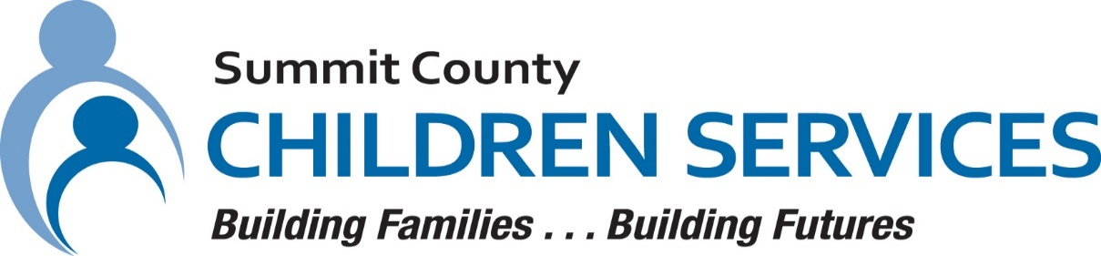

MEDIA RELEASE

Summit County Children Services 264 South Arlington Street Akron, Ohio 44306

FOR IMMEDIATE RELEASE Contact: Ann Ream
Department Director, Community Relations

(330) 379-2070
Ann.Ream@summitkids.org

Summit County Children Services’ Nikaeda Griffie begins Minority Professional Leadership Development Program

AKRON, OHIO – October 2023 – Ms. Nikaeda Griffie, Social Services supervisor at Summit County Children Services (SCCS) is the first fellow from the State of Ohio to be selected for the AdoptUSKids, Minority Professional Leadership Development (MPLD) program. The 12-month MPLD program, a signature program of the AdoptUSKids collaborative, is designed for emerging minority leaders working in the child welfare field. MPLD participants are committed to pursuing systemic change for children and families who are moving toward or have already achieved permanency.

With over twenty years of experience in adoption, Ms. Griffie is one of twenty-three fellows representing 15 states from across the nation selected for Cohort 6, who are committed to growing professionally as a leader in serving children, youth, and families. Each fellow will devote time to leadership training and design and implement an action research project in their agency.

“My desire has always been and remains ensuring the best possible outcomes and equitable treatment for the children and families I work with,” stated Griffie. “I am interested in taking a more intensive look at the outcomes for minority children in permanent custody and using the data to build my action research project.”

In September 2024, upon successful completion of the program, Ms. Griffie will be recognized at a graduation celebration in Washington, D.C.

“We are proud to support Ms. Griffie throughout her journey in this program,” said Executive Director, Cassandra Holtzmann. “We are excited to have the opportunity for one of our leaders to participate in a leadership program that has the potential to improve outcomes for the children in our custody.”

For more information about Summit County Children Services, please visit summitkids.org

#####

