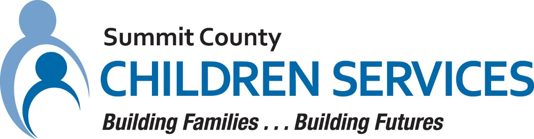

MEDIA RELEASE

Summit County Children Services 264 South Arlington Street Akron, Ohio 44306

FOR IMMEDIATE RELEASE Contact: Ann Ream
Department Director, Community Relations

(330) 379-2070
Ann.Ream@summitkids.org

Summit County Children Services Recognizes September as National Kinship Care Month

AKRON, OHIO – September 2023 – Summit County Children Services (SCCS) recognizes Kinship Care Month and the importance of grandparents, relatives and other caregivers helping to raise children when their parents are unable.

SCCS works to keep families together whenever possible, but when it is unsafe for a child to remain with their parents, relatives and kinship families often step forward to offer their love and care to children in need. SCCS believes that all children deserve a safe, stable, and permanent home.

“When children experience being out of the parental home, Kinship Care helps them by maintaining family and cultural ties that are so important,” said Cassandra Holtzmann, Executive Director of SCCS. “In addition, staying connected to siblings is more likely to occur when a child is in Kinship Care and that is a priority for SCCS.”

In Summit County, over 45% of children in the custody of SCCS are placed with kin. The number of children living with grandparents and other relatives continues to grow. Last year, SCCS had an average of 344 children placed with kinship families.

For more information about Summit County Children Services, please visit summitkids.org.

#####

