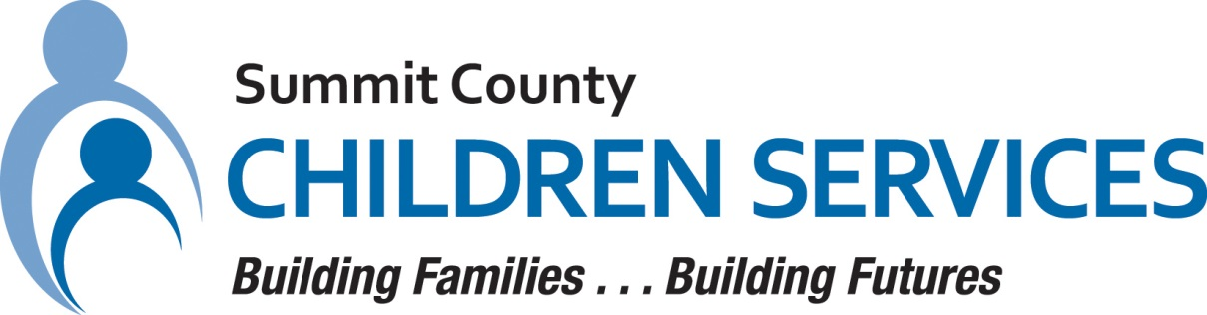

MEDIA RELEASE

Summit County Children Services 264 South Arlington Street Akron, Ohio 44306

FOR IMMEDIATE RELEASE Contact: Ann Ream
Department Director, Community Relations
(330) 379-2070
Ann.Ream@summitkids.org

Summit County Children Services' Jessica Miller Promoted to Department Director

AKRON, OH – August 2023 – Jessica Miller, JD, MSSA, LSW, LCDCIII has recently been promoted to Department Director, Client Rights & Quality Improvement at Summit County Children Services (SCCS).

Ms. Miller began her career in child services as a protective caseworker at SCCS nearly 13 years ago. After four years at the agency, she moved into a coordinator position within the Client Rights & Quality Improvement Department and in 2019, Ms. Miller was promoted to supervisor. In this role, she first oversaw the records auditing team and later led, managed, and contributed to quality improvement activities with staff members responsible for data mining and analysis, research, agency policy and procedures, and compliance reports.

Ms. Miller earned a Bachelor of Social Work from Cleveland State University, a Master of Science in Social Administration from Case Western Reserve University, and a Juris Doctor from the University of Akron School of Law. She is also a graduate of both the SCCS Leadership Academy and the Summit County Child and Family Leadership Exchange. In addition, Ms. Miller served as a Peer Reviewer assisting with the Federal Child and Family Services Review (CFSR).

Prior to child welfare, Ms. Miller began her career in tobacco prevention before serving as a social worker in residential care for youth with co-occurring mental health and substance abuse disorders.

“I am thrilled to be member of the senior leadership team. Our department is committed to our mission, and will remain focused on the safety, permanency, and well-being of all children served,” said Ms. Miller.

For more information about Summit County Children Services, please visit our website at summitkids.org.

####

