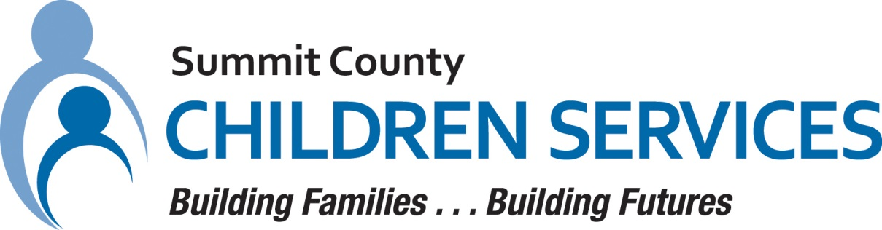

MEDIA RELEASE

Summit County Children Services 264 South Arlington Street Akron, Ohio 44306

FOR IMMEDIATE RELEASE Contact: Ann Ream
Department Director, Community Relations
(330) 379-2070
Ann.Ream@summitkids.org

Summit County Children Services Seeking Monetary Donations for Back to School

AKRON, OH – July 2022 – Summit County Children Services (SCCS) is seeking monetary contributions to support their Back-to-School program. A new school year is fast approaching, and SCCS wants to ensure that children receiving services will begin school prepared with the essential supplies that will help them achieve success.

In 2021, SCCS provided services to one out of every 12 children in Summit County and currently has over 800 children in agency custody. With the generous support of the community, SCCS will be able to support these children by providing those items needed for back to school. These monetary donations offer relief to caretakers by reducing the financial burden of school preparation.

“A key to children to succeed in the classroom is to help ensure they have the appropriate back to school items to increase their potential for learning. This community is so generous to our children in need so I am confident we will be able to provide this added support to these children and families in need,” said Cassandra Holtzmann, Executive Director.

For more information about how to donate to the SCCS Back-to-School program, please go to their website at summitkids.org (under the Community Action tab) or mail checks to Summit County Children Services, 264 S. Arlington Street, Akron, Ohio 44306.

####

